
Marwadi University
Department of Information Technology

Practical 5: Deploy a Web Application on AWS.

Solution :

Step 1. Go to AWS dashboard, search and select Elastic BeanStalk
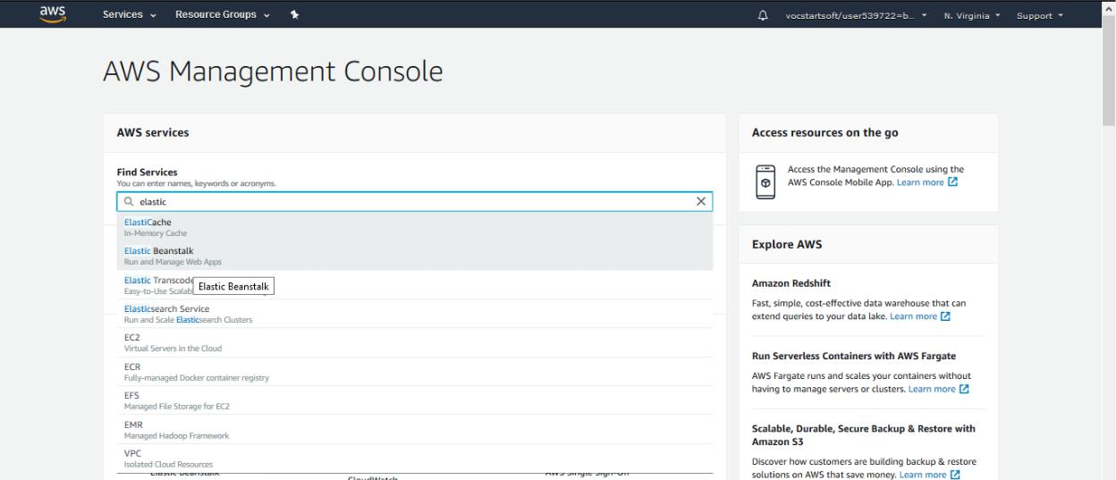

Step 2. Select Create New Application at Elastic Beanstalk Dashboard
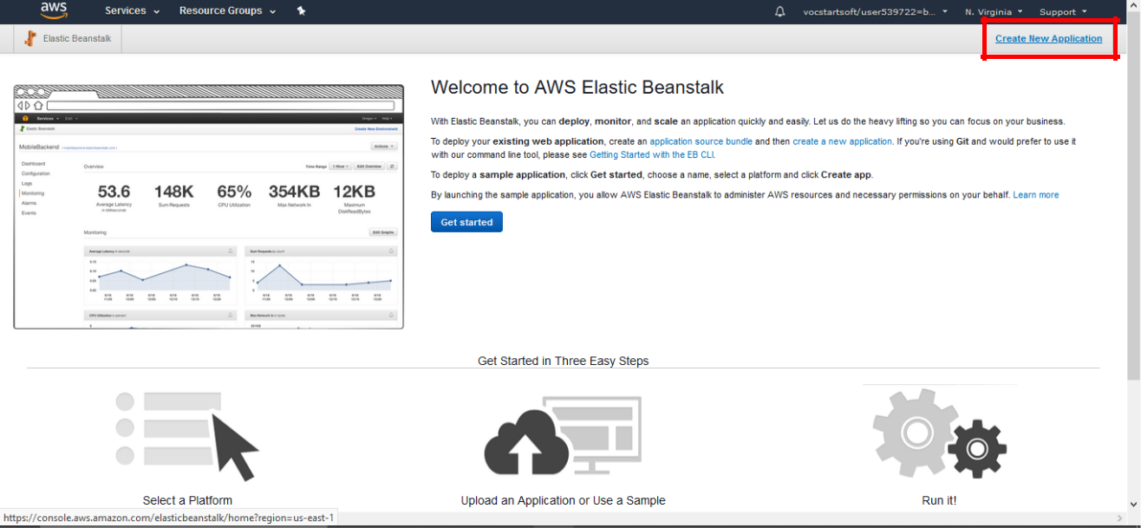

Marwadi University
Department of CE/IT

Step 3. Write any name in Application name here we have mentioned testApplication, then select create option.
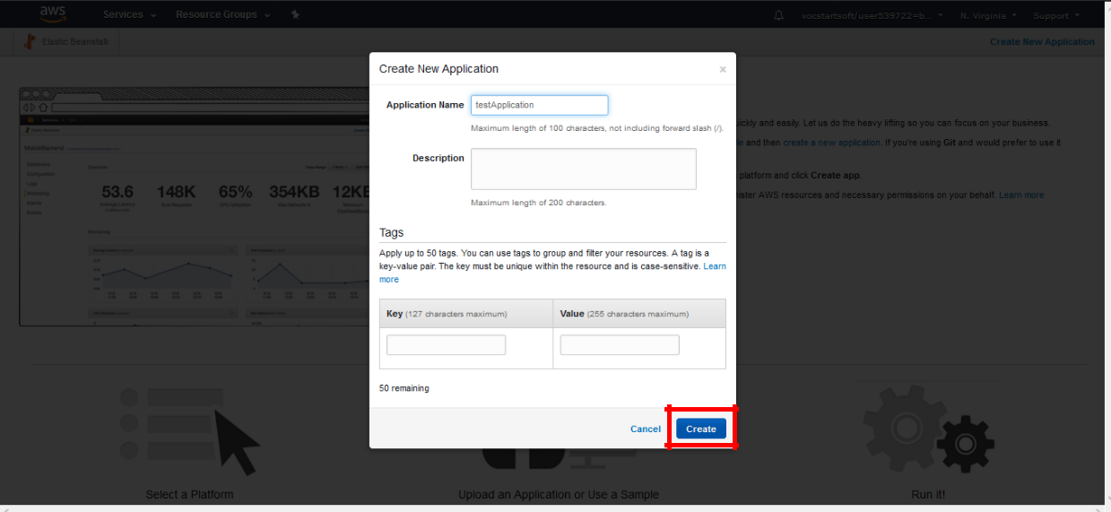

Step 4. Now the application dashboard will open. In the dashboard select Create one now
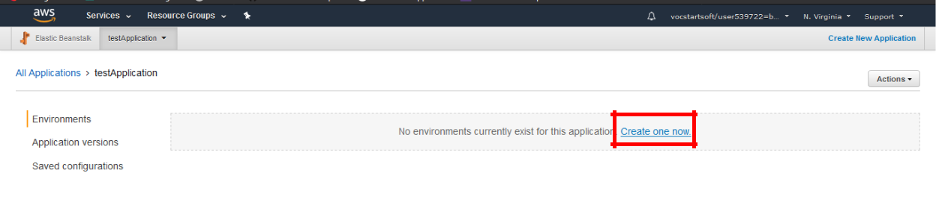

Step 5. Select Web Server Environment and proceed
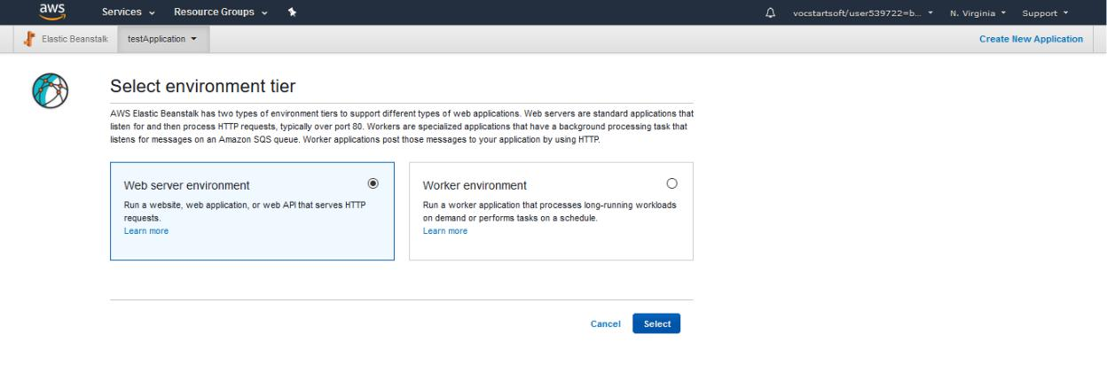

Marwadi University
Department of CE/IT

Step 6. As we are deploying a java web application select tomcat in platform.
Continue further by selecting Create Environment
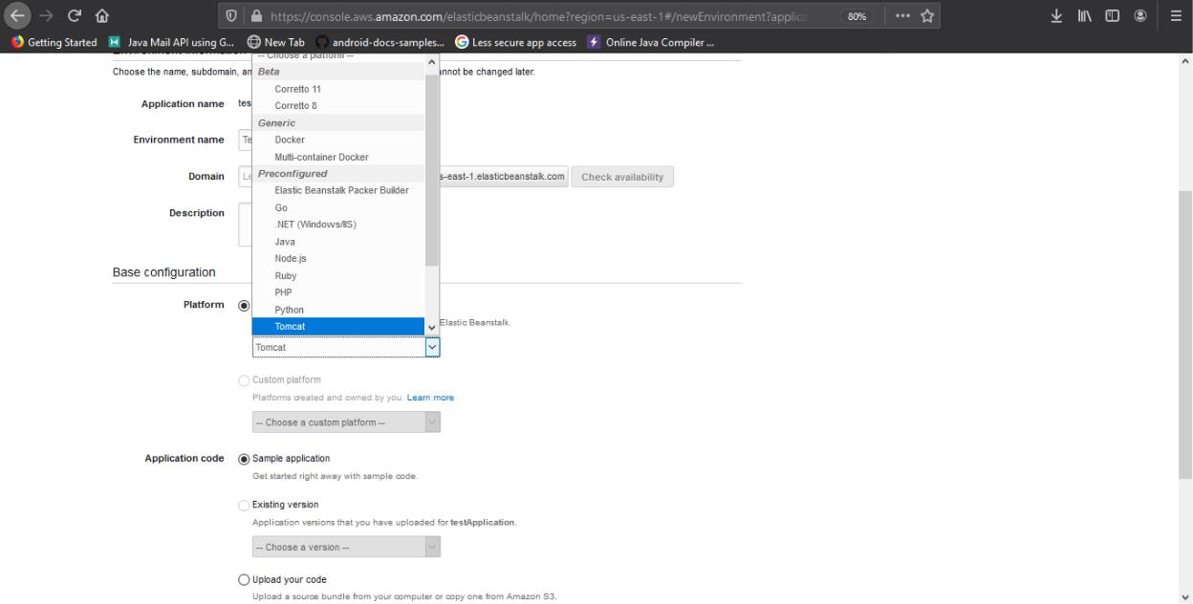

- It will take time to create the server so wait.
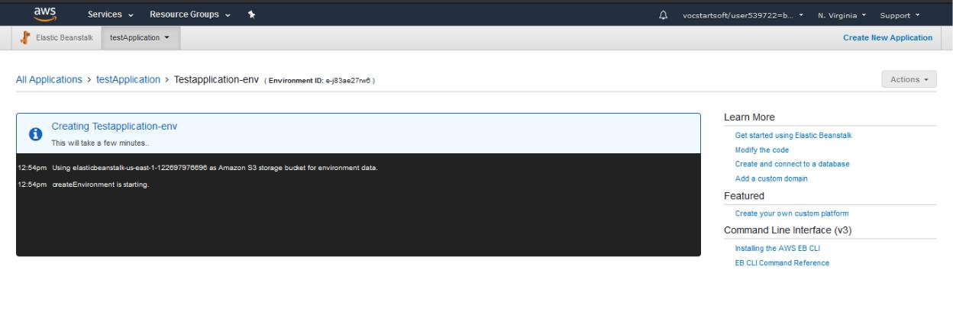

Marwadi University
Department of CE/IT

Step 7. Create a Web Application for AWS in Netbeans 7.1 Open Netbeans and select Java Web
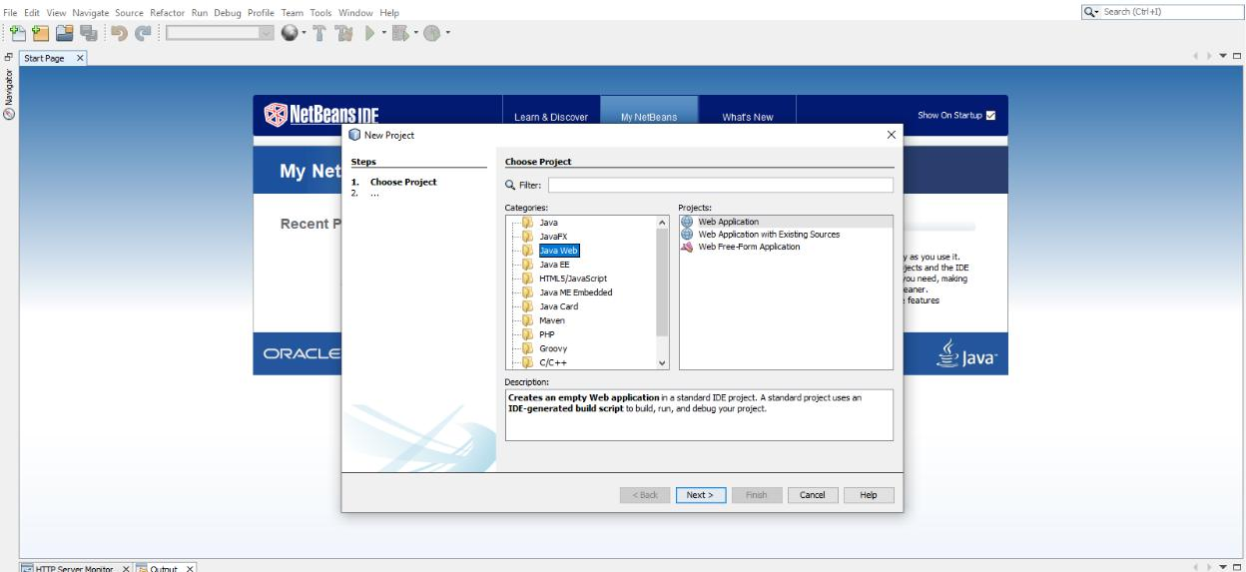

7.2 Name the app : testaws 7.3 In server select Apache tomcat & finish
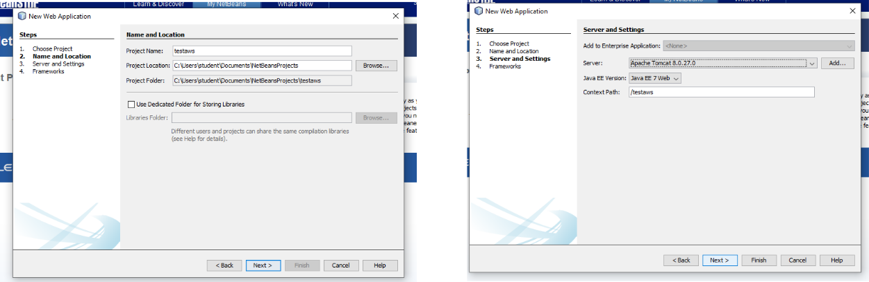

7.4 Delete the index.html file from the package
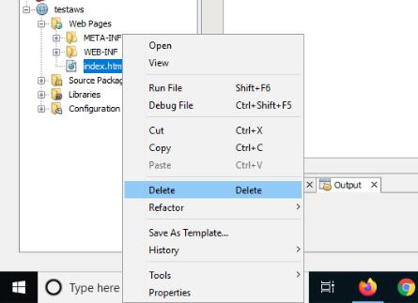

Marwadi University
Department of CE/IT

7.5 In the webpage create a new jsp File 7.6 Name it as index
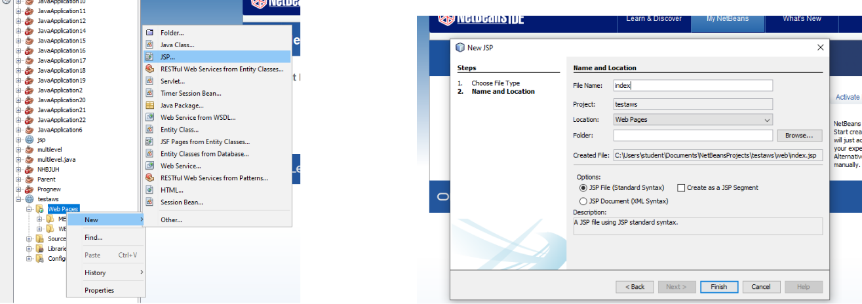

7.7 Create a form tag after hello world line
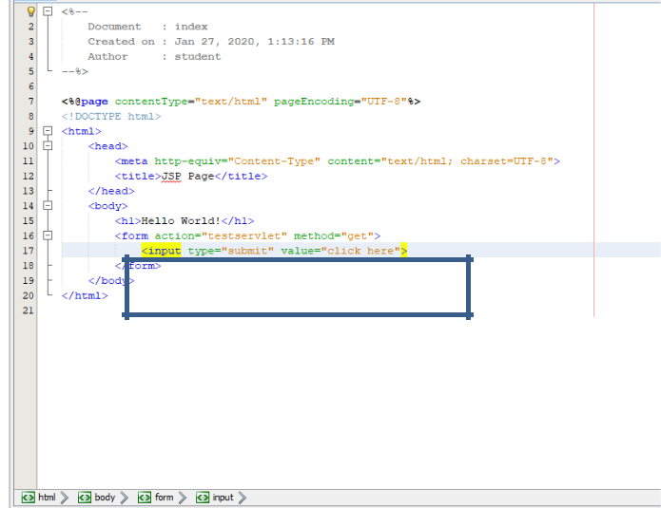

7.8 Create a new java package in source package 7.9 Name the package as com.test
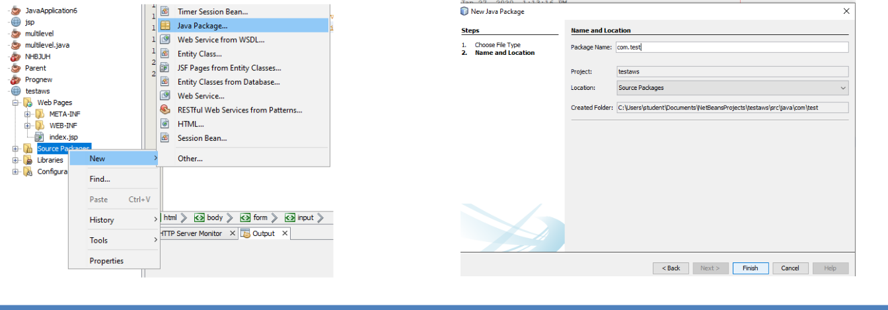

Marwadi University
Department of CE/IT

7.10 Create a new servlet in com.test package 7.11 Name it as testservelet and proceed
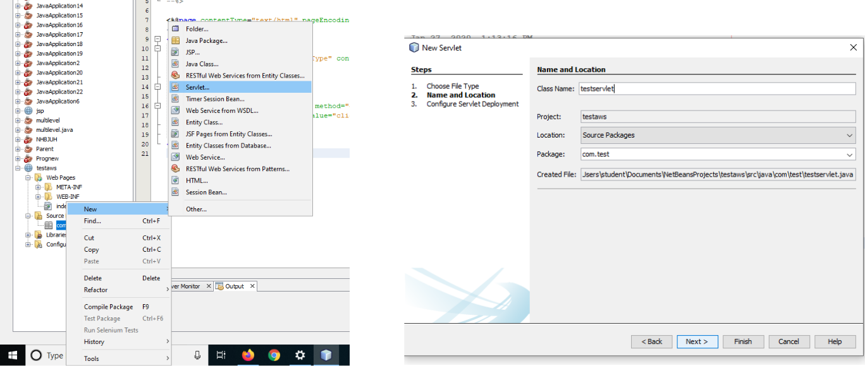

7.12 In the Configure Servlet Deployment check Add information to deployment descriptor (web.xml)
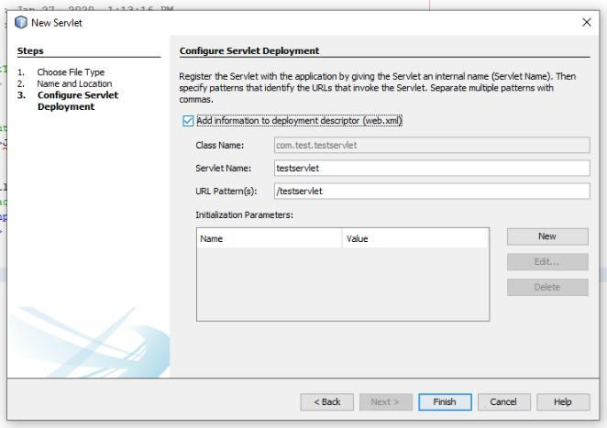

7.13 Now select the Web App and select option Clean and Build
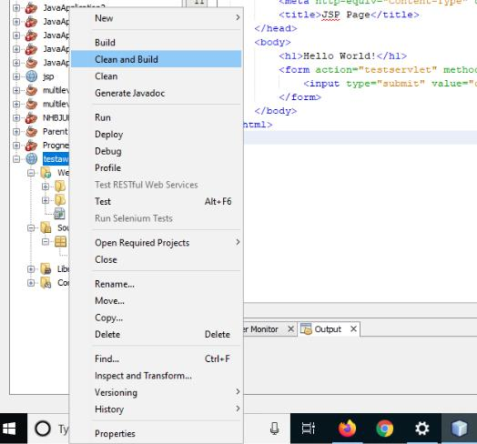

Marwadi University
Department of CE/IT

Step 8. Since we build the app, there will be a .war file created in project dist folder.
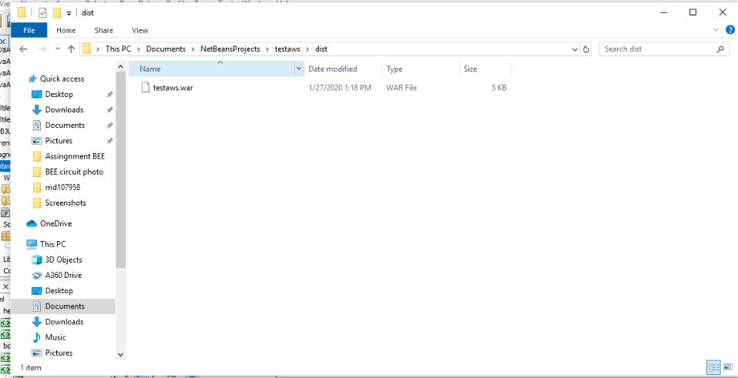

Step 9. Upload and deploy

9.1 Go to the AWS dashboard and select the application which you created. Select Upload and Deploy option.
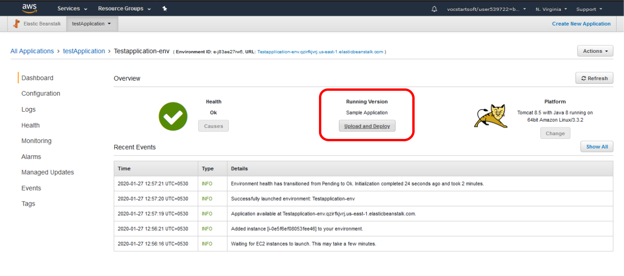

Marwadi University
Department of CE/IT

9.2 In the location of the .war file and upload it. Name it as testaws1 or whatever you want.
Deploy it after the war file is uploaded.
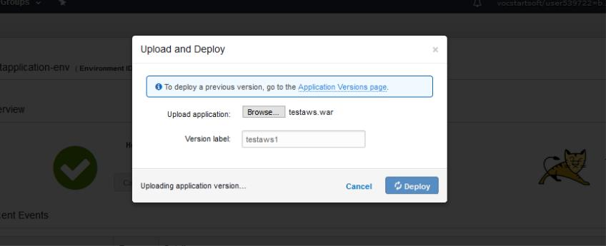

Step 10. Checking the app in online or not ?

10.1 When the app is successfully deployed, the pop-up will be gone and a link will be generated.
Click on that link and a new tab will be opened, with the deployed application.
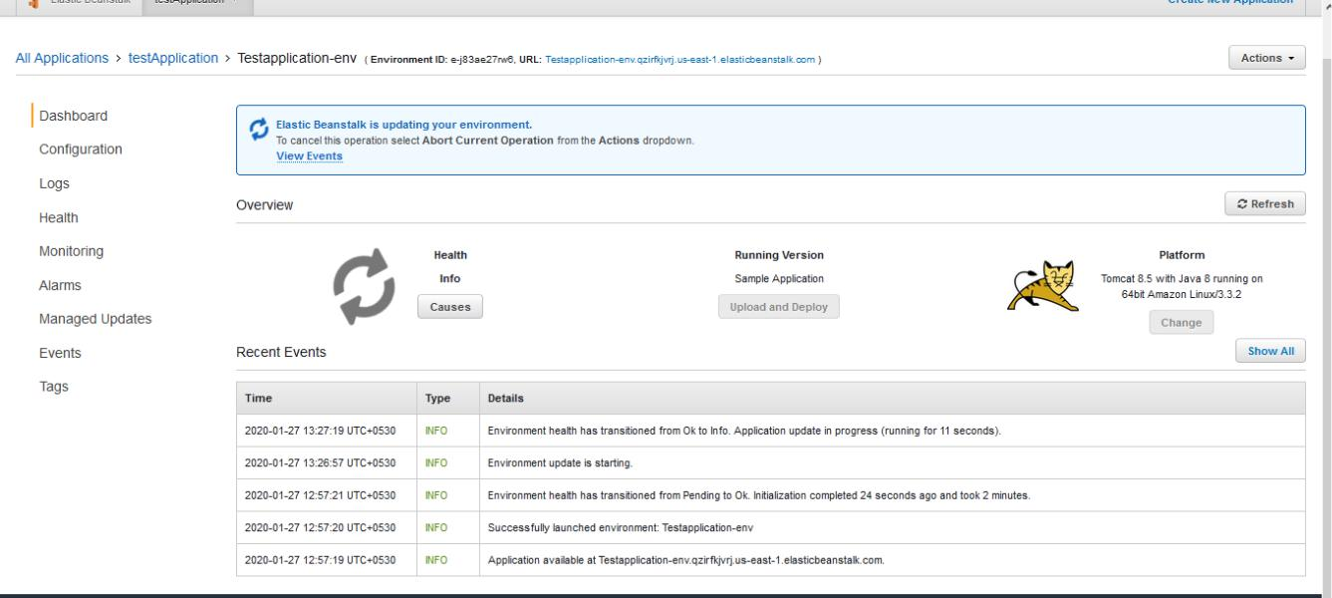

Marwadi University
Department of CE/IT

10.2 As we can see the application is working. We a click here button which we created.
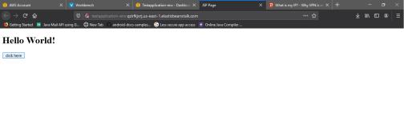

10.3 As we click on the click here button we are redirected to testservlet. Hence the application is running.
